**Cheltenham Paint Festival 2023 - ‘The People’s Paint Festival’**

**Cheltenham Paint Festival launches app guide to 2023 event**

After the event being briefly cancelled earlier this year, Cheltenham Paint Festival 2023 is now back on and bigger than ever! This year they’re doing their tallest mural (7 stories high), their longest mural, painting a whole multi-storey car park and have more artists than ever before! To help visitors find the works they are also now launching their own map and audio guide available in 12 languages!

Visitors to the Cheltenham Paint Festival (#CPF23) can now download the app for a full tour experience, including a map of all art locations from this, and previous years, complete with a full audio guide.

Launched today, the Cheltenham Paint Festival audiovisual tour is available for £2.99 from Guide.ai on Google Play and Apple iOS app stores. You can also visit the festival website to download it.

Festival director, Andy Davies, says using ai to create the guide enabled him to include the full gallery of Cheltenham’s public art well in time for the live event, which takes place on Saturday 29 and Sunday 30 July.

“Downloading the app before the festival begins will help people plan their walking or cycling tour to see art being created live and visit the iconic works that are located across our town. It’s also going to be a brilliant tourist attraction, as fans of street art will be able to use it throughout the year.”

“This guide is not just for 2023, although it will highlight the new work that we’re looking forward to making in 30 key locations this year. We’ve created an exhibition guide that includes work created since 2017 and will support the festival in future years, too.”

**Cheltenham Paint Festival (29-30 July) phone app includes:**

* A narrated guide to street art across Cheltenham created since 2017
* Spotlight on locations for new work created 29-30 July 2023
* Audio guide to artists and their work
* Evolving gallery of retrospective and forthcoming professional publicly located artwork

Download Cheltenham Paint Festival audio map guide

#CPF23 #CheltenhamPaintFestival #CheltPaintFest #Cheltenham #Gloucestershire #graffiti #StreetArtUK #graffuk #ukgraff #ukgraffiti

**Note to editors:**Cheltenham Paint Festival was founded in 2017 by artist Andy ‘Dice’ Davies, to create public art across the town. Held each year, the festival attracts leading UK and international street artists to paint in free-to-view locations, creating a legacy of large-scale diverse artwork. The festival takes place in locations across Cheltenham, 29-30 July 2023.

**Contact**

Andy Davies

Director, Cheltenham Paint Festival

T: 07932 823642  
E: director@cheltenhampaintfestival.co.uk

‘The People’s Paint Festival’

Street art for everyone in our community

**#CPF23, 29-30 July**

To join in, visit:

[www.cheltenhampaintfestival.co.uk/](https://www.cheltenhampaintfestival.co.uk/) - or <https://guide-ai.com/auto-redirect>

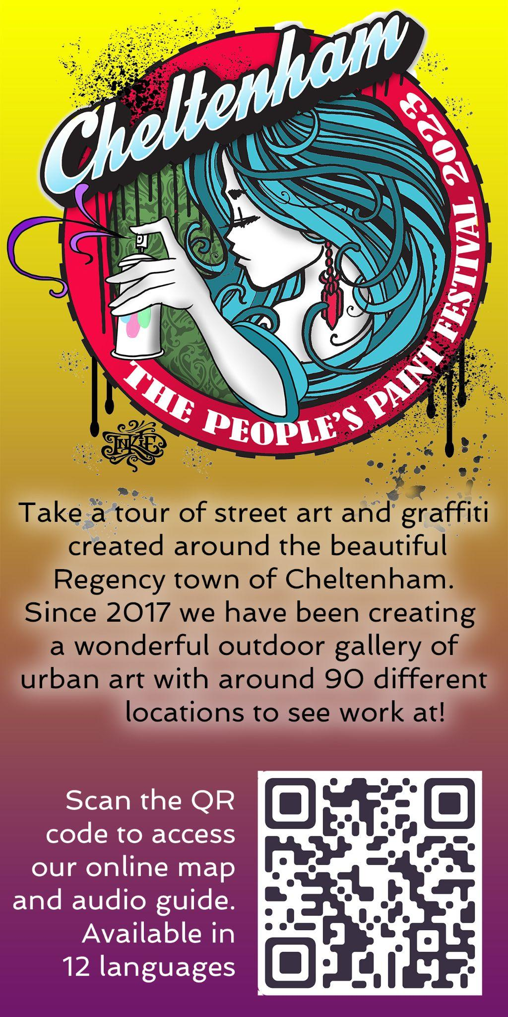Handout for the festival

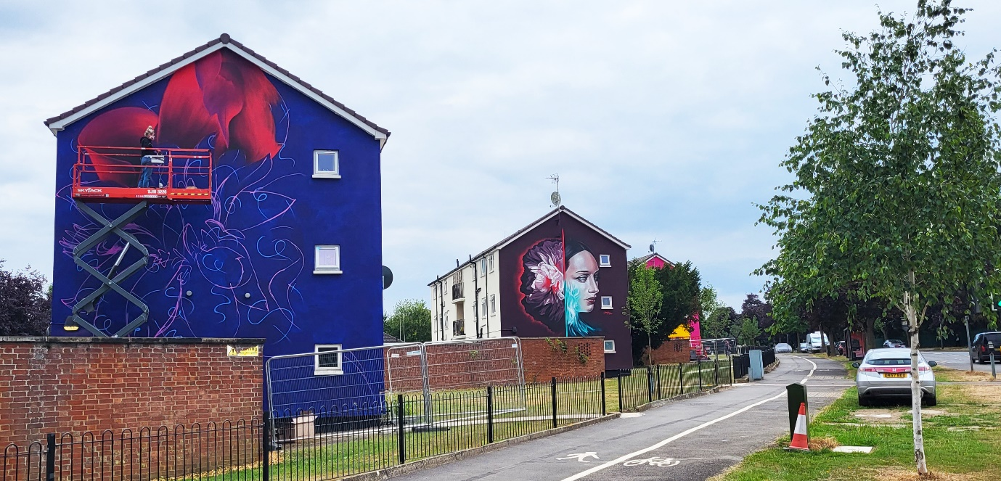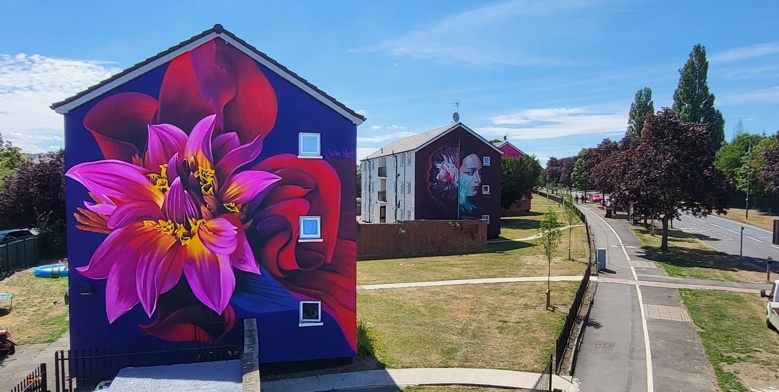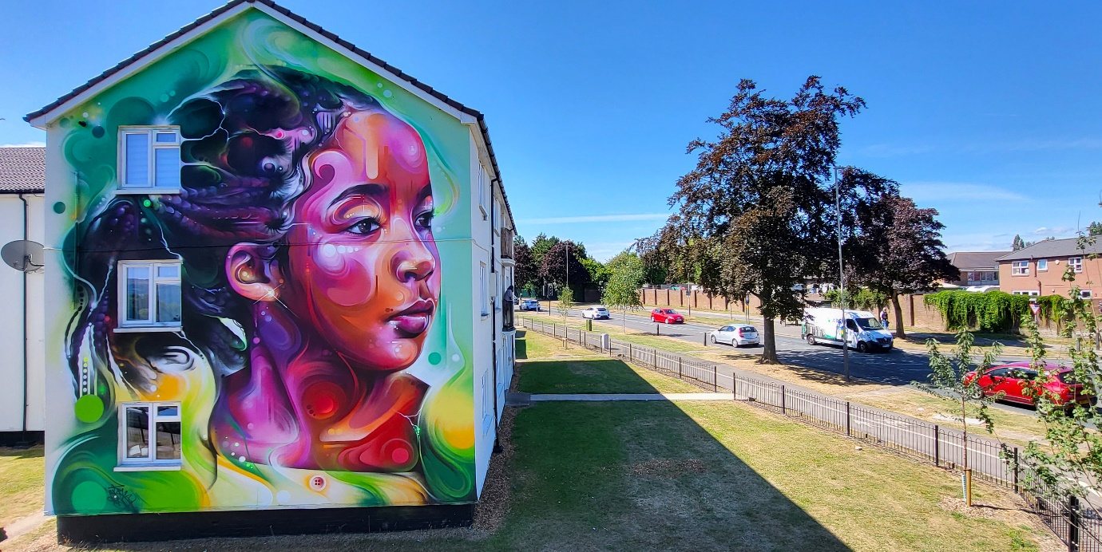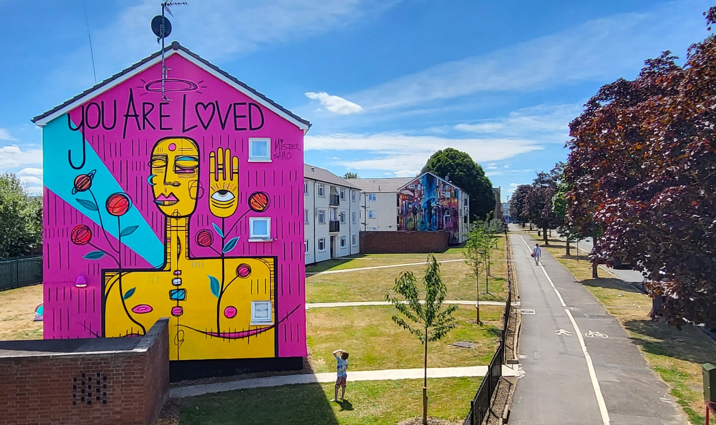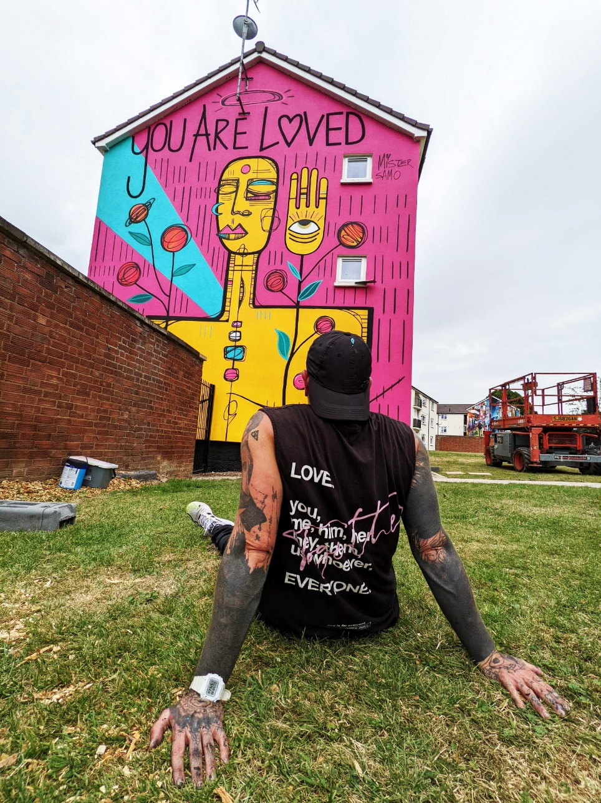

Pics 1 and 2 Sophie Mess

Pic 3 Mr Cenz

Pics 4 and 5 Mr Samo

Mr Samo looking at his work with back to camera

Next page Sophie Mess painting

Festival Director Andy ‘Dice’ Davies

ALL PHOTOGRPAHS BY DIRECTOR ANDY DICE DAVIES AND CAN BE USED IN PUBLICATIONS

